About the Medicare Diabetes Prevention Program (MDPP)
National Diabetes Prevention Program (National DPP) providers are eligible to join the Medicare Diabetes Prevention Program (MDPP) expanded model. The MDPP includes an evidence-based set of services aimed at preventing the onset of type 2 diabetes among Medicare beneficiaries with an indication of prediabetes. As of April 1, 2018, MDPP services are covered for eligible beneficiaries with no cost-sharing through Medicare-enrolled MDPP suppliers. The goals and curriculum of the MDPP are the same as the National DPP.
How to Use This Guide
This guide is for National DPP provider organizations that have achieved preliminary or full recognition with the Centers for Disease Control and Prevention (CDC) Diabetes Prevention Recognition Program (DPRP) and wish to apply to become MDPP suppliers. An organization that wishes to provide MDPP services to beneficiaries and bill Medicare for those services must enroll in Medicare as an MDPP supplier.
This guide will walk you through the process of applying to become an MDPP supplier. This packet contains two sections: (1) MDPP Initial Application Preparation Checklist and (2) MDPP Supplier Online Initial Enrollment Application Guide. Once you have completed the steps outlined in this guide, you will be ready to begin your MDPP Initial Application. You must complete the MDPP Initial Application to enroll as an MDPP supplier.

- The MDPP Initial Application Preparation Checklist (page 2) outlines the information and materials you will need on hand to complete the MDPP Initial Application. Gather the information and materials in the checklist before starting the MDPP Initial Application.
- The MDPP Supplier Online Initial Enrollment Application Guide (page 7) outlines the initial enrollment steps you need to take to before beginning the MDPP Initial Application. This guide does not include instructions for completing the MDPP Initial Application.
Additional Support
If you have any further questions about the application process, please contact your Medicare Administrative Contractor (MAC). MACs are contractors who, among other responsibilities, process Medicare enrollment applications and claims for Medicare FFS providers and suppliers. In order to receive updates on the status of your application and to determine when you may receive an immediate response regarding the status, please contact your MAC.
New York MAC: Jurisdiction K
Phone number: 888-379-3807

MDPP Initial Application Preparation Checklist
This checklist is for National DPP provider organizations that have achieved preliminary or full recognition with the Centers for Disease Control and Prevention (CDC) Diabetes Prevention Recognition Program (DPRP) and wish to apply to become MDPP suppliers. It contains a list of items and information about your organization that you will need to have on hand to complete the MDPP Initial Application. This checklist continues to undergo improvements, and we welcome feedback. To provide feedback, email EBI_Referrals@health.nyc.gov.

Visit the links below for more information:
- Diabetes Prevention Recognition Program (DPRP): https://www.cdc.gov/diabetes/prevention/pdf/dprp-standards.pdf

- Medicare Diabetes Prevention Program (MDPP): https://innovation.cms.gov/initiatives/medicare-diabetes-prevention-program/

- Medicare Enrollment Application – MDPP Suppliers (print version): https://www.cms.gov/Medicare/CMS-Forms/CMS-Forms/Downloads/CMS20134.pdf
NOTE: Providers can complete the MDPP Initial Application online or in print. This is the print version of the application. You can only view the online version after completing the Online Initial Enrollment Application.

MDPP Initial Application Preparation Checklist
Item |  | Description | Notes
Organization Information
 | Medicare Identification Number (if issued): | Medicare Identification Numbers, also known as Medicare numbers, CCN, P-Tan, Oscar, or Provider numbers, are Medicare-only numbers issued to providers by Medicare Administrative Contractors (MACs) upon enrollment to Medicare.
 | How the business is registered with the IRS | e.g., proprietary or non-profit
 | Incorporation date (if applicable)
 | Type of organization  Structure of provider/supplier | e.g., corporation, government owned, partnership sole proprietor, sole owner of a limited liability company, limited liability company, disregarded entity
CDC Recognition Status
To request the information below, email dprpAsk@cdc.gov
 | DPRP organizational code | When the DPRP approves your application, you will receive a unique organizational code to be used to submit data.
 | Copy of certificate or determination letter demonstrating recognition status | An MDPP supplier must have and maintain preliminary or full recognition with the CDC DPRP.
 | Effective date | The effective date is the first day of the month following the DPRP approval date and is used to determine due dates for required data submissions.
MDPP Location & “Special Payments” Address
 | Administrative location address | An administrative location is a physical location associated with the MDPP supplier’s operations where they are the primary operator in the space, where coaches are based or dispatched from, and where MDPP services may or may not be furnished (e.g., group practice office, hospital, clinic, nursing facility).
 | Community setting address | A community setting is a location where the MDPP supplier provides MDPP services outside of their administrative locations. A community setting is a location open to the public and not primarily associated with the supplier (e.g., church basements, multipurpose rooms in recreation centers).
 | Medicare ID Number (if issued) | The Medicare ID Number can be found in the National Plan and Provider Enumeration System (NPPES) Validation Letter or Medicare Contractor correspondence associated with the location.
Final Adverse Legal Actions
This section captures information on final adverse legal actions, such as convictions, exclusions, revocations, and suspensions.
All applicable final adverse legal actions must be reported, regardless of whether any records were expunged or any appeals are pending.
 | Final adverse legal action | e.g., conviction, exclusion, revocation, or suspension
 | Date (when it occurred)
 | Who took the legal action? | e.g., the federal or state agency or the court/administrative body that imposed the action
 | Resolution | i.e., how was the adverse action resolved?
MDPP Coach Information
 | Coach(es) first and last name
 | Social Security Number (SSN)
 | National Provider Identifier (NPI) | A National Provider Identifier or NPI is a unique 10-digit identification number issued to health care providers in the United States by the Centers for Medicare and Medicaid Services (CMS). Organizations may obtain NPIs on behalf of coaches or coaches may obtain their own NPI. You can create an NPI here: https://nppes.cms.hhs.gov/#/
 | Eligibility start date (if applicable) | The date should represent the date the coach will begin furnishing MDPP services.
Organization Control
If applicable, you will need information about all organizations that have 5 percent or more (direct or indirect) ownership interest of, any partnership interest in, and/or managing control of, the supplier identified, as well as information concerning any adverse legal action taken against that organization.
 | Does the applicant have any organizations with ownership interest and/or managing control to report? | If yes, you will need the following items.
 | Organization information | e.g., organization name, address, contact information, etc.
 | Legal business name, Taxpayer Identification Number (TIN) | A Taxpayer Identification Number (TIN) is an identification number used by the Internal Revenue Service (IRS). You can retrieve your number from the IRS by calling its customer service number, 800-829-1040.
 | Applicant’s relationship to the organization | e.g., 5 percent or greater direct/indirect owner, authorized official, delegated official, partner, director/officer, contracted managing employee, managing employee (W-2).
Patient Records Storage Location
 | Storage location name and address | If you store beneficiaries’ medical records at a location other than the administrative location(s) listed in Section 4A of the application, complete this section with the address of the storage location.
 | Electronic storage | If yes, identify where/how these records are stored below. This can be a website, URL,  in-house software program, online service, vendor, etc. This must be a site that can be accessed by the CMS or its contractor’s AC if necessary.
Billing Agency
A billing agency is a company or individual that you contract with to prepare and submit your claims.
If you use a billing agency, you are responsible for the claims submitted on your behalf.
 | If the billing agency is an individual, you will need their:  - Tax Identification Number (TIN, TIN Type)  - Billing agency address | TIN Types include SSN, Employer ID number (EIN) or Individual Taxpayer ID number (ITIN).
If the billing agency is an organization, you will need their:
- Legal business name
- Tax Identification Number (TIN)
- Billing agency address
Electronic Funds Transfer (EFT)
 | Financial institution information | e.g., name, address, telephone, routing transit number, depositor account number, type of account (savings or checking).
 | Contact person information | The contact person at the MDPP Supplier who should be contacted with any questions regarding the EFT Authorization Agreement Submission  (e.g., full name, title, telephone, e-mail)
Required and/or Supporting Documentation Information
 | Copy/copies of all documentation from the CDC verifying recognition status | Email dprpAsk@cdc.gov for the recognition status verification letter.
 | A voided check or letter from a bank confirming account information
 | Copy of IRS form CP 575 or other official IRS communication confirming tax identification number and legal business name | You can retrieve a copy of the IRS Form CP 575 by calling the IRS Business Line at  1-800-829-4933.
 | Signed and completed certification statement | This form is located in the Required and/or Supporting Documentation Information section of the application.
 | Signed form CMS-588, Electronic Funds Transfer (EFT) Authorization Agreement | This form is located in the Required and/or Supporting Documentation Information section of the application.
Optional Documentation
 | Receipt of pay.gov payment information | The supplier pays the required application fee of $569 via www.pay.gov upon initial enrollment. The enrollment fee is due upon initial enrollment and revalidation (every 5 years for MDPP suppliers). Payment is due online or via mail prior to completing and submitting the enrollment application. Organizations may apply for a hardship exemption to the application fee. Find more information about the hardship exemption here, starting on page 3: https://www.cms.gov/Outreach-and-Education/Medicare-Learning-Network-MLN/MLNMattersArticles/downloads/MM7350.pdf
 | Other documentation requested by your Medicare Administrative Contractor (MAC)

MDPP Supplier Online Initial Enrollment Application Guide
This guide is for National Diabetes Prevention Program (National DPP) provider organizations that have achieved preliminary or full recognition by the Centers for Disease Control and Prevention (CDC) Diabetes Prevention Recognition Program (DPRP) and wish to apply to become MDPP suppliers. This guide outlines the steps you will take to begin your MDPP Online Initial Enrollment Application. Please refer to the checklist to review the items and information you will need in order to successfully complete and submit your application.
This guide continues to undergo improvements, and we welcome feedback. To provide feedback, email EBI_Referrals@health.nyc.gov.

Visit the links below for more information:
- Diabetes Prevention Recognition Program (DPRP) : https://www.cdc.gov/diabetes/prevention/pdf/dprp-standards.pdf

- Medicare Diabetes Prevention Program (MDPP): https://innovation.cms.gov/initiatives/medicare-diabetes-prevention-program/

- Medicare Enrollment Application – MDPP Suppliers (print version): https://www.cms.gov/Medicare/CMS-Forms/CMS-Forms/Downloads/CMS20134.pdf
NOTE: Providers can complete the MDPP Initial Application online or in print. This is the print version of the application. You can only view the online version after completing the Online Initial Enrollment Application.

MDPP Supplier Online Initial Enrollment Application Guide
1. To get started, you will need a National Provider Identifier (NPI) number. If the provider does not have an NPI number, apply for a NPI Number at https://nppes.cms.hhs.gov/?userType=Provider#/  - A National Provider Identifier or NPI is a unique 10-digit identification number issued to health care providers in the United States by the Centers for Medicare and Medicaid Services (CMS). | 2. Use your Center for Medicare and Medicaid Services (CMS) ID and Password to log in to the Provider Enrollment and Chain/Ownership System (PECOS) at https://pecos.cms.hhs.gov/pecos/login.do  - PECOS supports the Medicare Provider and Supplier enrollment process by allowing registered users to securely and electronically submit and manage Medicare enrollment information.
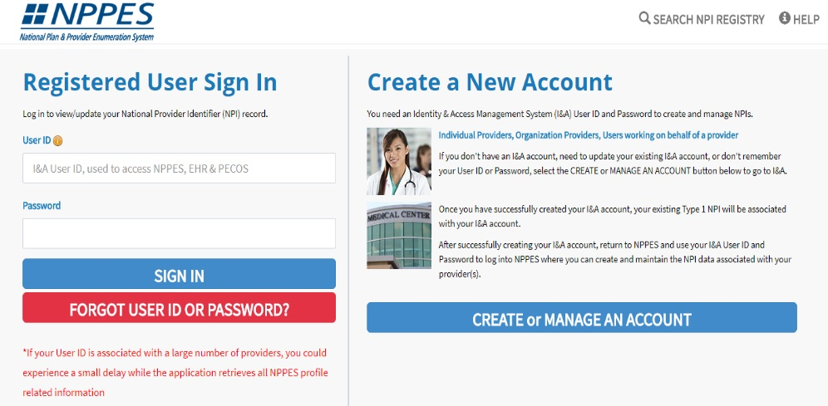 | 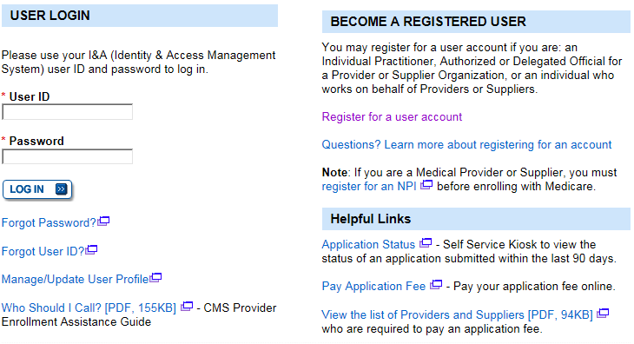

3. Select My Associates | 4. Select Create Initial Enrollment Application
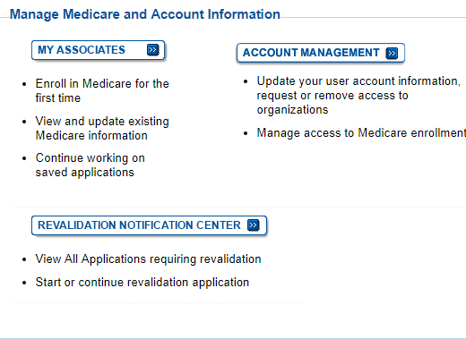
5. Search for the name of the provider for whom the application is being created. Select the provider name and click Next Page | - Select Medicare Diabetes Prevention Program Supplier (MDPP) and click Next Page
- Click Continue to MDPP Enrollment | - Complete the MDPP Questionnaire and click Start Application
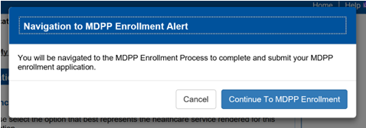
- Begin the MDPP Initial Application.
You will be directed to the Enrollment Summary page. You may refer to the Preparation Checklist to complete all sections in the left-side panel of the MDPP Initial Application screen.
